Activity 1: Build a Min Heap and Max Heap

- Min Heap
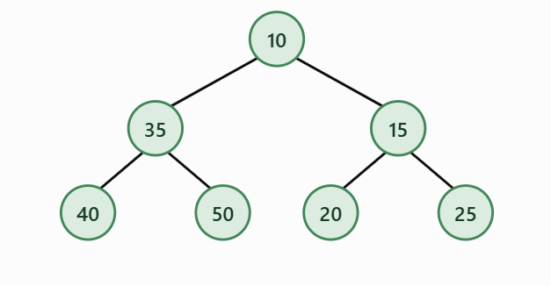
Array representation: [10, 35, 15, 40, 50, 20, 25]
Root value: 10
- Max Heap
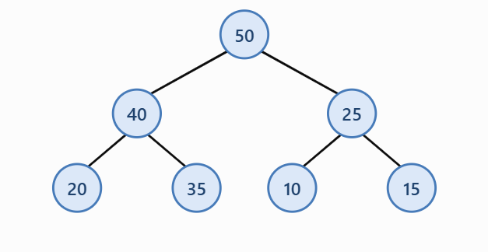
Array representation: [50, 40, 25, 20, 35, 10, 15]
Root value: 50

Objective: Understand the properties of min heaps and max heaps.
3. Difference Between Min Heap and Max Heap
A Min Heap has the smallest number at the top, while a Max Heap has the biggest number at the top. Both arrange numbers in a binary tree, but their rules are different. Basically, Min Heap = smallest first, and Max Heap = biggest first.

Objective: Compare the arrangement of values in both heaps.
Instructions
Given the numbers:
35, 20, 15, 40, 50, 10, 25
- Insert the numbers one at a time into a min heap.
- Draw the resulting binary tree.
- Write its array representation.
- Repeat the process using a max heap.
- Identify the root value of each heap.
- Explain the difference between the two structures.
Expected output: Two heap diagrams, two array representations, and a short explanation.
Activity 2: Heap Operations Challenge
Objective: Practice insertion, extraction, and heapify operations.
Start with this min heap:
[5, 10, 15, 20, 25, 30]
Perform the following operations in order:

1.Insert 3
Insert 3 at the end, then swap it with 15 and 5.
Swaps: 3 ↔ 15, then 3 ↔ 5
Heap after operation: [3, 10, 5, 20, 25, 30, 15]
Root value: 3

2. Extract the Minimum
Remove 3, move 15 to the top, then swap it with 5.
Swap: 15 ↔ 5
Heap after operation: [5, 10, 15, 20, 25, 30]
Root value: 5

3. Insert 8
Insert 8 at the end, then swap it with 15.
Swap: 8 ↔ 15
Heap after operation: [5, 10, 8, 20, 25, 30, 15]
Root value: 5

4. Extract the Minimum Again
Remove 5, move 15 to the top, then swap it with 8.
Swap: 15 ↔ 8
Heap after operation: [8, 10, 15, 20, 25, 30]
Root value: 8

Complete the table below.
Operation | Heap array after operation | Root value
Initial heap | [5, 10, 15, 20, 25, 30] | 5
Insert 3 | [3, 10, 5, 20, 25, 30, 15] | 3
Insert 8 | [5, 10, 8, 20, 25, 30, 15] | 5
Extract minimum | [5, 10, 15, 20, 25, 30] | 5
Extract minimum | [8, 10, 15, 20, 25, 30] | 8
Heap operations help keep the smallest value at the top of a Min Heap. When we insert or remove a number, we swap values if needed to keep the heap in the correct order. Basically, we just need to follow the heap rules so the structure stays organized.

